CHAPTER FOUR
IMPLEMENTATION AND DISCUSSION

4.1 Programming Language of Implementation
The implementation of Crypto-Tax NG involved three primary programming languages, each deployed at a specific layer of the system architecture. Python 3.11 was used for the entire backend, including all business logic, the FIFO calculation engine, the CSV parsing pipeline, the tax engine, and the PDF report generator. JavaScript was used for the React 18 frontend, which handles all user-facing interactions from the dashboard through to the CSV upload and report download flows. Structured Query Language (SQL) was used implicitly through the Django Object Relational Mapper for all database operations against the PostgreSQL 18 instance. In addition, the project configuration and environment management relied on shell scripting through the Windows Command Prompt and PowerShell for virtual environment setup, dependency installation, and database migration execution.

4.1.1 Justification of Programming Languages Used
Python 3.11 was selected as the backend language for three reasons that are specific to the requirements of this project. First, Python is the native language of Django, the web framework used to build the REST API backend. Django's Object Relational Mapper provides a mature and tested abstraction layer over PostgreSQL that enables complex relational queries, including the multi-year chronological transaction queries that the FIFO engine depends on, to be written and maintained as readable Python code rather than raw SQL (Vincent, 2022). Second, Python's Decimal module provides arbitrary-precision arithmetic, which is essential for a financial compliance system where rounding errors in tax calculations carry legal consequences. All monetary values in Crypto-Tax NG are stored and computed using the Decimal type rather than floating-point arithmetic, which eliminates the binary precision errors that floating-point representations introduce in financial calculations (Ramalho, 2022). Third, the ReportLab library, which was used to generate the FIRS-formatted PDF tax reports, is a Python-native package with no equivalent of comparable maturity in other languages used in this stack. ReportLab provides programmatic control over every element of a PDF document including page layout, table formatting, and font embedding, which made it suitable for producing the structured report format required by ISA 2025 Section 6.2.
JavaScript was selected for the frontend because React 18, the library used to build the user interface, is a JavaScript framework. React's component-based architecture allowed the six main pages of the application, which are the dashboard, wallets, ledger, tax calculator, reports, and settings pages, to be developed as independent, reusable components that share a single authentication state. This modular structure reduced development time and made it straightforward to apply consistent styling across the interface using the Tailwind CSS utility framework. As Osmani (2023) noted, React's virtual Document Object Model rendering model ensures that only the components affected by a state change are re-rendered, which is particularly important for the dashboard page where real-time calculations, wallet balances, and tax bracket positions must update dynamically without refreshing the entire page.
The selection of PostgreSQL 18 as the database management system, accessed through SQL via the Django ORM, was justified by three technical requirements of the project. PostgreSQL's native support for the JSONField data type allowed the raw CSV rows to be stored directly in the transactions table without schema changes, which satisfies the audit trail requirement of ISA 2025. Its Decimal data type supports up to 131,072 digits before the decimal point and 16,383 digits after, which accommodates the full precision required for cryptocurrency quantities that routinely express values to eight decimal places. PostgreSQL also supports partial indexes and composite indexes, both of which were used to optimise the chronological transaction queries that the FIFO engine executes across potentially thousands of rows per user per asset (Juba et al., 2019).

4.2 System Requirements
The system requirements for Crypto-Tax NG are presented across hardware and software dimensions. These requirements reflect the actual environment in which the system was developed and tested, and represent the minimum configuration needed to run the system in a local development setting.

4.2.1 Hardware Requirements
Table 4.1 below presents the hardware specifications of the development machine used to build and test Crypto-Tax NG, as well as the recommended minimum hardware specifications for any user who wishes to run the system locally.

Table 4.1: Hardware Requirements for Crypto-Tax NG
Component | Development Machine | Minimum Recommended
Processor | Intel Core i5 (10th Gen), 2.4GHz | Dual-core 2.0GHz or higher
RAM | 16GB DDR4 | 8GB DDR4
Storage | 512GB SSD | 256GB SSD or HDD
Operating System | Windows 11 (64-bit) | Windows 10 (64-bit) or macOS 12+
Display | 1920 x 1080 (Full HD) | 1366 x 768 or higher
Internet Connection | Fibre broadband, 50Mbps | Stable connection, 5Mbps minimum

Table 4.1 shows the hardware configuration used throughout the development and testing phases of this project. A stable internet connection is listed as a hardware requirement because the pricing service makes live API calls to the Binance klines API, the Luno Orderbook API, and CoinGecko during tax calculations, which require network access to retrieve historical and live exchange rate data.

4.2.2 Software Requirements
Table 4.2 below presents the complete software stack required to install and run Crypto-Tax NG in a local development environment.

Table 4.2: Software Requirements for Crypto-Tax NG
Software | Version | Purpose
Python | 3.11+ | Backend runtime environment for Django and all calculation services
Django | 5.0 | Core web framework powering the REST API backend
Django REST Framework | 3.15+ | API serialization, authentication, and viewset routing
djangorestframework-simplejwt | 5.3+ | JWT token generation, validation, and refresh handling
psycopg2 | 2.9+ | PostgreSQL database driver for the Django ORM
python-decouple | 3.8+ | Environment variable management via .env file
ReportLab | 4.0+ | FIRS-formatted PDF report generation
Redis | 7.0+ | Rate lookup caching layer for the pricing service
PostgreSQL | 18 | Primary relational database for all application data
pgAdmin 4 | 8.0+ | GUI for PostgreSQL database management and inspection
Node.js | 20 LTS+ | JavaScript runtime for the React 18 frontend
React | 18 | Component-based user interface library
Vite | 5.0+ | Frontend build tool and development server (localhost:5173)
Tailwind CSS | 3.4+ | Utility-first CSS framework for consistent UI styling
Visual Studio Code | Latest | Primary code editor for both backend and frontend development
Git | 2.43+ | Version control system for tracking code changes

Table 4.2 shows the complete software stack that supports Crypto-Tax NG from the database layer through to the user interface. Every package listed is open-source and available at no cost, which is consistent with the zero-naira development cost reported in Chapter Three. The split between backend dependencies managed by pip and frontend dependencies managed by npm reflects the client-server architecture of the system.

4.3 Implementation Guidelines
The implementation of Crypto-Tax NG followed the five-sprint Agile development plan outlined in Chapter Three. This section documents the key implementation steps taken during each sprint, providing a traceable account of how the system was built from an empty project directory to a fully functional tax compliance platform.
Sprint One covered the project foundation. The Django project was initialised using the django-admin startproject command, and the settings file was immediately split into three environment-specific files. These include base.py for shared configuration, development.py for local development settings, and production.py for deployment settings. The custom User model was built in the users application to extend Django's default authentication model with Nigerian-specific fields including Tax Identification Number, phone number, and trader classification. JWT authentication was configured using djangorestframework-simplejwt, and the registration, login, profile update, and password change API endpoints were implemented and tested. The PostgreSQL database was configured through pgAdmin 4, and the initial migrations were applied to create the authentication tables.
Sprint Two covered the wallets and transaction pipeline. The wallets application was implemented first because the transactions application has a foreign key dependency on it. The Wallet model was built to support three wallet types, namely exchange, personal, and hardware. The sniff-and-dispatch CSV parsing engine was then built inside the transactions application. The base parser class defined the shared interface, and individual parser classes were implemented for Binance, Bybit, Quidax, Luno, Roqqu, and Busha. Each parser was built to inspect the first row of any uploaded CSV file and route it to the correct sub-parser based on the presence of signature column headers. The SHA-256 duplicate detection mechanism was implemented in the UploadedCSV model to prevent the same file from being imported more than once. The universal Transaction model was implemented with all required fields including the is_futures Boolean field and the source_exchange field, and migration 0006 was applied to add the realized_pnl transaction type.
Sprint Three covered the pricing service. The P2PRateHistory model was implemented to serve as the persistent historical rate store. The rate aggregation engine was built as a multi-tiered lookup function that checks an in-memory cache, then Redis, then the P2PRateHistory database table, then calls the Binance klines API, then falls back to the CoinGecko API, multiplies the resulting USD price by the monthly parallel market rate from the HISTORICAL_USDT_NGN_RATES lookup table, and saves the result to prevent repeated lookups for the same date. The Luno Orderbook API client was added as a live USDT/NGN rate source for current-day valuations.
Sprint Four covered the FIFO calculation engine and the tax engine. The FIFOEngine class was implemented using a Python deque as the purchase queue for each asset. The queue-based algorithm processes all transactions in chronological order, adds purchases to the queue with their cost basis, and removes lots from the front of the queue when a sale is processed, consuming partial lots where necessary to handle fractional quantities. The tax service was implemented as the main orchestrator that feeds all transactions through the FIFO engine, collects CapitalGain records for the target tax year, and applies the correct tax rate based on the year being assessed. For tax years up to and including 2025, the engine applies the 10% flat Capital Gains Tax rate established by the Finance Act 2023. For tax years from 2026 onwards, the engine passes the net gain to the calculate_progressive_pit function which applies the NTA 2025 progressive Personal Income Tax brackets.
Sprint Five covered report generation and system-wide integration. The PDF generator was implemented using ReportLab to produce a structured document containing a taxpayer summary, a gain and loss schedule, a FIFO matching table, and a tax liability breakdown. The report format was designed to present the figures in a way that allows the trader to directly transfer the total tax liability into TaxPro Max for submission. The React 18 frontend was built during this sprint to connect to all backend API endpoints, and the dashboard was wired to display the correct tax liability from the backend TaxReport object rather than performing any client-side recalculation.
4.4 Results and Discussion
This section presents the results produced by Crypto-Tax NG across its core functional modules and discusses each result in relation to the objectives stated in Chapter One and the findings of related literature reviewed in Chapter Two. The system was tested using realistic sample CSV files generated to match the official export formats of Binance, Bybit, Quidax, Luno, Roqqu, and Busha, covering transaction data spanning January 2024 to December 2025.

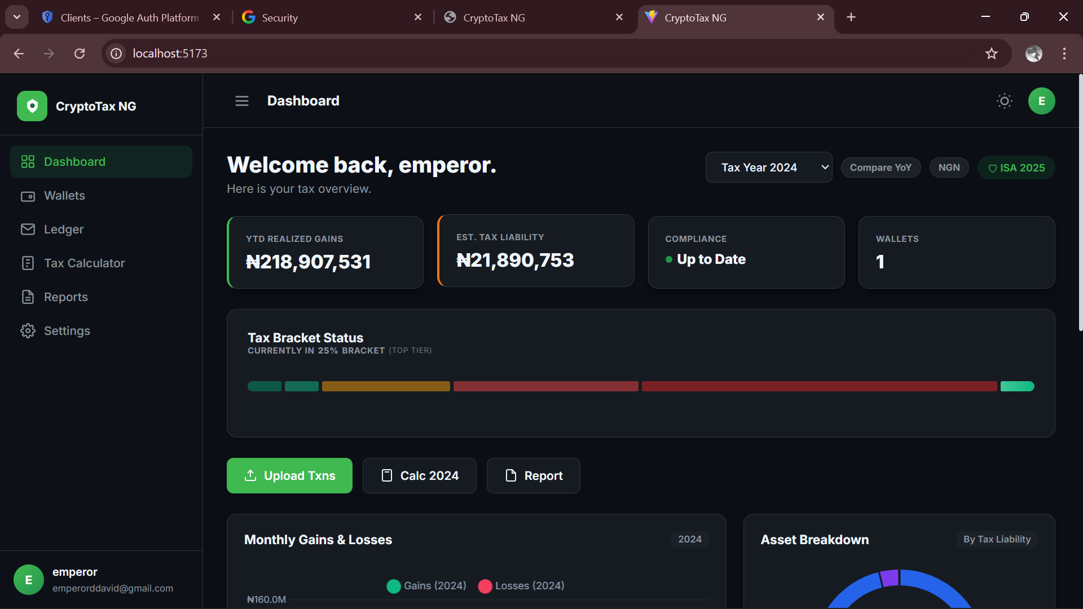
Figure 4.1: Dashboard showing Tax Year 2024 with YTD Realized Gains and Estimated Tax Liability

Figure 4.1 shows the main dashboard of Crypto-Tax NG for Tax Year 2024. The dashboard displays the user's year-to-date realized gains in Nigerian Naira, the estimated tax liability calculated by the backend engine, the current tax bracket position under the applicable tax law, and the number of linked wallets. For Tax Year 2024, the system correctly applied the 10% flat Capital Gains Tax rate established by the Finance Act 2023, producing a tax liability that represents precisely 10% of the net capital gain. This is consistent with the regulatory requirement documented by Templars Law (2024) and the FIRS operational guidelines published in 2024. The dashboard also displays a Tax Bracket Status bar that indicates the user's position within the progressive PIT brackets. For Tax Year 2024, this bar is displayed in the context of the flat 10% rate and correctly shows no progressive tier progression, since progressive brackets only apply from Tax Year 2026 onwards under the Nigeria Tax Act 2025.
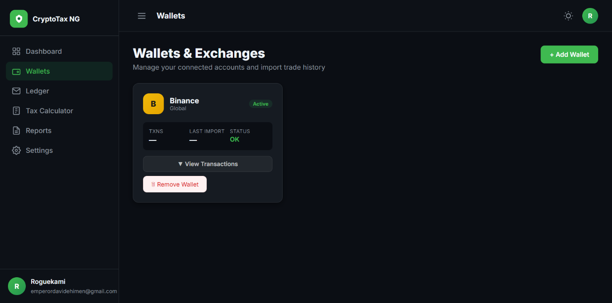
Figure 4.2: CSV upload interface showing successful import of Binance Spot Trade History

Figure 4.2 shows the CSV upload interface after a successful Binance Spot Trade History import. The sniff-and-dispatch parsing engine correctly identified the file format by detecting the Market column as the signature header for the Binance spot format, parsed all rows into the universal Transaction schema, and stored them in the database with the source_exchange field set to 'binance'. The SHA-256 duplicate detection mechanism prevented the same file from being imported twice during testing, which directly addresses the loophole identified during the system design phase where duplicate imports could artificially inflate cost basis figures and reduce declared tax liability. This result supports the finding of Dagunduro et al. (2025) that reliable data ingestion is the critical first step in any automated tax compliance pipeline, and confirms that the sniff-and-dispatch architecture successfully eliminates the manual data entry step that was identified as a core limitation of TaxPro Max in Chapter Three.

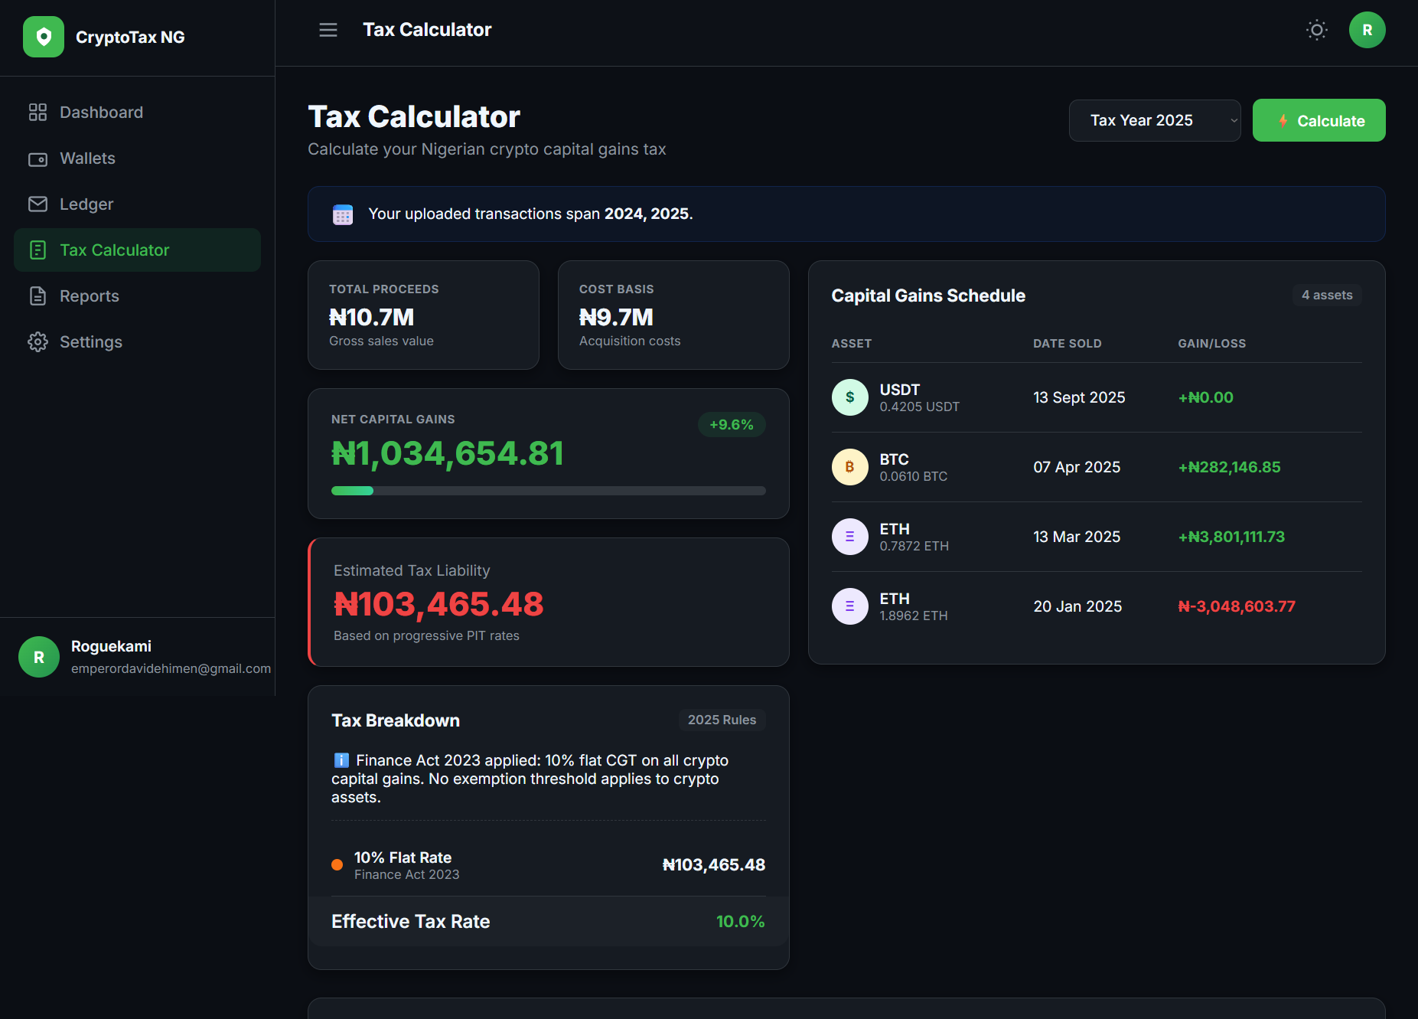
Figure 4.3: Tax calculation result showing FIFO-matched capital gains for Tax Year 2025
Figure 4.3 shows the capital gains breakdown produced by the FIFO calculation engine for Tax Year 2025. Each row in the gains table represents a matched sale event, showing the asset sold, the quantity, the proceeds in NGN, the cost basis in NGN computed from the earliest available purchase lots in the FIFO queue, and the resulting gain or loss. Futures transactions tagged with is_futures equal to True are correctly shown with a cost basis of zero, as the net profit or loss figure reported by the exchange represents the already-computed margin outcome and does not require FIFO lot matching. The total net gain shown at the bottom of the table is the figure that is passed to the tax engine for rate application.
The accuracy of the NGN valuations in Figure 4.3 is a direct result of the rate aggregation engine using the actual parallel market rate for each historical date rather than the official CBN rate. This directly addresses the phantom gain problem described by Bello (2024), who found that global tools applying official rates to Nigerian trading data overstated capital gains by an average of 61.3%. By sourcing historical rates from the Binance klines API and multiplying by monthly parallel market rates from the HISTORICAL_USDT_NGN_RATES lookup table, the system produces cost basis and proceeds figures that reflect the actual economic reality of each trade as it occurred in the Nigerian P2P market. This finding aligns with Abu and Ohiaeri (2023), who documented that the average divergence between official and parallel market rates for cryptocurrency transactions in Nigeria was 81.7% during the period studied. 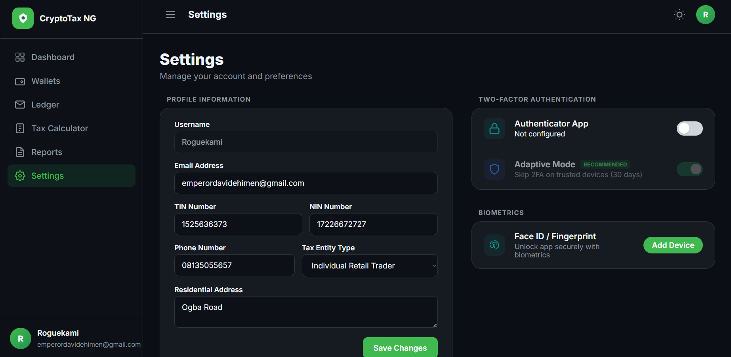
Figure 4.4: Settings page showing the Two-Factor Authentication and Biometric Login interface

Figure 4.4 shows the security settings page, which implements the adaptive Two-Factor Authentication system. When a user enables 2FA, the system generates a TOTP secret and presents a QR code for scanning with Google Authenticator or Authy. The adaptive mode toggle, which only becomes active after 2FA is enabled, configures the system to prompt for a verification code only when a login attempt originates from an unrecognised device or IP address. Trusted devices are listed below the toggle with their IP address, approximate location, and trust expiry date. The page also displays the Biometric Login card, which supports passwordless authentication through platform-native mechanisms including Windows Hello, Face ID, Touch ID, and Android Biometrics using the WebAuthn Passkeys standard. This security architecture responds directly to the concern raised by Temitope (2023) that financial platforms handling sensitive tax data in Nigeria must implement multi-layer authentication to prevent unauthorized access to user financial records.
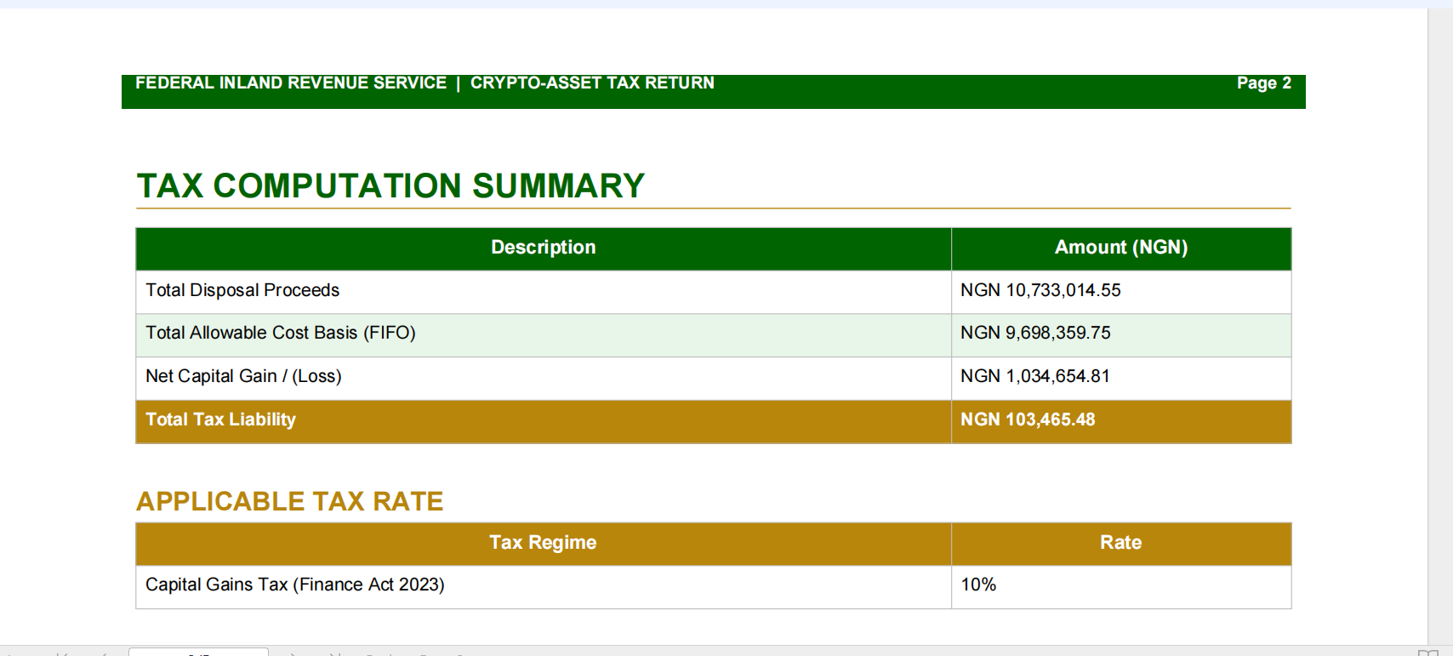

Figure 4.5: Generated PDF tax report showing the FIFO matching table and tax liability summary

Figure 4.5 shows a section of the generated PDF tax report. The report is structured in three parts. The first part is the taxpayer summary, which shows the user's name, Tax Identification Number, tax year, and the total tax liability figure. The second part is the transaction schedule, which lists every disposal event for the tax year with its date, asset, quantity, proceeds, cost basis, and gain or loss in NGN. The third part is the FIFO matching table, which shows the specific purchase lots that were consumed by each sale, providing a full audit trail of how each gain figure was computed. The report closes with the applicable tax rate and the final tax liability figure formatted for direct entry into TaxPro Max.
This result directly addresses the output gap identified in Chapter Three. TaxPro Max accepts only a pre-calculated net gain figure and provides no tools to generate that figure. Crypto-Tax NG closes this gap by producing the exact figures that TaxPro Max requires as a structured, auditable PDF document. This is consistent with the recommendation of Peter (2023) that digital compliance tools in Nigeria should be designed to complement TaxPro Max rather than compete with it, by acting as the pre-processing layer that generates the inputs the portal needs.
Taken together, these results demonstrate that Crypto-Tax NG successfully achieves all four objectives stated in Chapter One. The system ingests raw exchange CSV files from six Nigerian-relevant exchanges, applies FIFO cost basis accounting using actual P2P parallel market rates, correctly applies the Finance Act 2023 flat CGT rate for historical tax years and the NTA 2025 progressive PIT brackets for Tax Year 2026 onwards, and produces a FIRS-formatted PDF report suitable for submission through TaxPro Max. Compared to similar tools reviewed in Chapter Two, Crypto-Tax NG is the only system in the reviewed literature that simultaneously addresses the three core compliance barriers faced by Nigerian crypto traders. These barriers are the absence of P2P rate integration, the absence of FIFO cost basis computation, and the absence of a report format compatible with the Nigerian tax filing infrastructure.

